Séquence : I'm a journalist !

Scénario
Domaine public
Classe : Terminale Professionnelle
ACL: production orale en continu

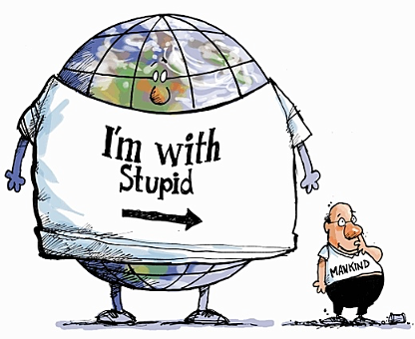  Illustration 1: http://www.absolutebodo.com/?p=6600 | 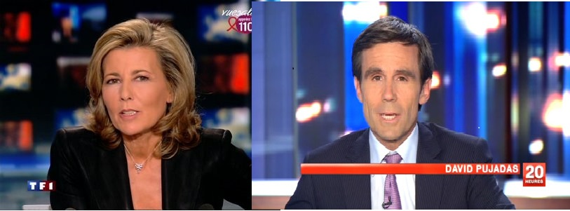  Illustration 2: http://www.marketing-professionnel.fr/wp-content/uploads/2011/03/claire-chazal-laurent-delahousse.jpg  http://telecaps.infos-tele.fr/wp-content/uploads/David-Pujadas-France-2-29-ao%C3%BBt-2013-2.jpg

Mission : You are a journalist for BBC.
You are asked to do and present a report answering two questions :
« Is Earth dying? If so, how and why? And what can Mankind do to avoid this? ».
This is an ORAL task.

Niveau visé : B1

You MUST : - Speak for at least 1 minute without any notes.
- Please mind your pronunciation!
- Use all the elements studied in class (articles, pictures, audio etc.)
- Introduce yourself
- Have a problematic and a 2 or 3 parts plan
- Have a conclusion.

You CAN : Use pictures to illustrate your thoughts or make a video !

Retour de l’enseignant à l’issue de la séquence :
Si la thématique n'était pas source de motivation au départ, petit à petit, avec ou grâce aussi à l'actualité (préparation de la COP21), les élèves ont voulu réaliser un travail très minutieux au niveau des posters réalisés. Toutefois, la production orale reste fragile et l'exercice sans notes difficile mais néanmoins, cela a provoqué une prise de conscience du travail qu'il faudra fournir pour réussir l'épreuve de CCF.

Ressources utilisées :

http://www.ilfattoquotidiano.it/2015/08/13/earth-overshoot-day-2015-esaurite-tutte-risorse-del-pianeta-da-oggi-stiamo-depredando-la-terra/1956752/
http://www.theweeklyobserver.com/wp-content/uploads/2015/08/Earth-Overshoot-Day-1.jpg

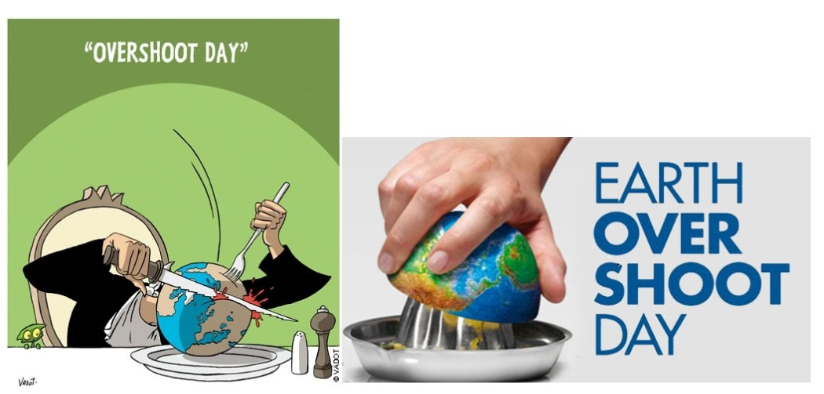

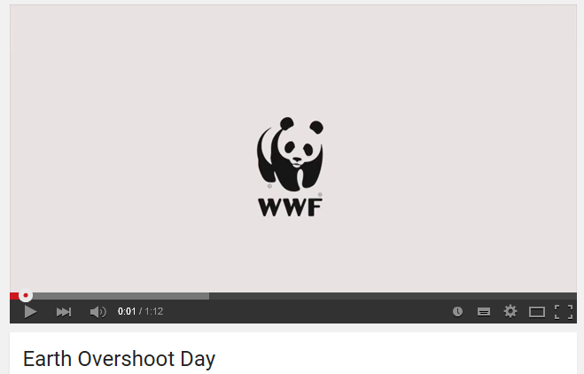
https://www.youtube.com/watch?v=0gajDuCL1xc

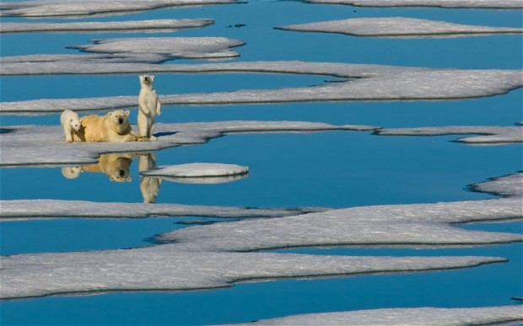
http://i.telegraph.co.uk/multimedia/archive/02511/globalwarming_2511421b.jpg

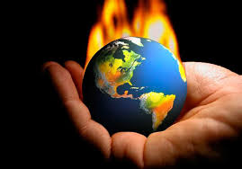
http://www.livescience.com/37003-global-warming.html

Global warming is the gradual heating of Earth's surface, oceans and atmosphere. Scientists have documented the rise in average temperatures worldwide since the late 1800s.[...] Temperatures are projected to rise another 2 to 11.5 degrees F (1.133 to 6.42 degrees C) over the next 100 years.
Most of the leading scientific organizations in the world acknowledge the existence of global warming as fact, according to a NASA report. Furthermore, 97 percent of climate scientists agree that the rate of global warming trends the planet is now experiencing is not a natural occurrence, but is primarily the result of human activity. [...]
Human-caused global warming occurs when human activity introduces too much of certain types of gas into the atmosphere. More of this gas equals more warming. The atmospheric gases primarily responsible for the greenhouse effect are known as "greenhouse gases" and include water vapor, carbon dioxide (CO2), methane (CH4) and nitrous oxide (N2O). […]
The effects of global warming are already visible in many areas of the world. For example, in Montana's Glacier National Park, where about 150 glaciers were once located, only 25 glaciers larger than 25 acres remain, according to the U.S. Geological Survey (USGS). [...]

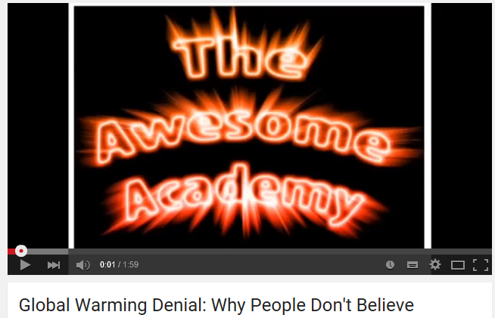
https://www.youtube.com/watch?v=w0LiQZltpC8

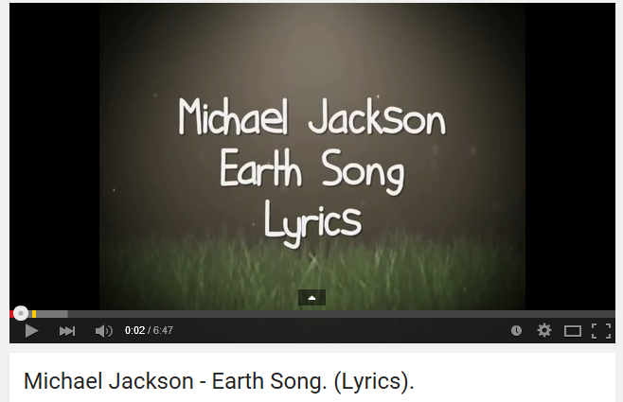https://www.youtube.com/watch?v=OstvvP8QuxQ

"Earth Song"
http://www.azlyrics.com/lyrics/michaeljackson/earthsong.html

What about _________________
What about __________________
What about all the______________________
That you said we were to gain...
What about killing fields
Is there a ______________
What about all the things
That you said was ___________ and ________________
Did you ever stop to notice
All the blood we've shed before
Did you ever stop to notice
The crying __________ the weeping shores?

Aaaaaaaaah Oooooooooh
Aaaaaaaaah Oooooooooh

What have we done to the ____________________
Look what we've done
What about all the ________________
That you pledge your only son...
What about _____________ fields
Is there a time
What about all the ____________________
That you said was yours and mine...
Did you ever stop to notice
All the _____________ dead from war
Did you ever stop to notice
The crying Earth the weeping shores

Aaaaaaaaah Oooooooooh
Aaaaaaaaah Oooooooooh

I used to dream
I used to glance beyond the _____________
Now I don't know where we are
Although I know we've drifted far

Aaaaaaaaah Oooooooooh
Aaaaaaaaah Oooooooooh
Aaaaaaaaah Oooooooooh
Aaaaaaaaah Oooooooooh

Hey, what about yesterday
(What about us)
What about the _____________
(What about us)
The heavens are falling down
(What about us)
I can't even breathe
(What about us)
What about apathy
(What about us)
I need you
(What about us)
What about ____________ worth
(Ooo, ooo)
It's our planet's womb
(What about us)
What about _______________________
(What about it)
We've turned kingdoms to dust
(What about us)
What about _____________________
(What about us)
Have we lost their trust
(What about us)
What about ____________ whales
(What about us)
We're ravaging the ____________
(What about us)
What about forest trails
(Ooo, ooo)
Burnt despite our pleas
(What about us)
What about the holy land
(What about it)
Torn apart by creed
(What about us)
What about the common man
(What about us)
Can't we set him free
(What about us)
What about children dying
(What about us)
Can't you hear them cry
(What about us)
Where did we go wrong
(Ooo, ooo)
Someone tell me why
(What about us)
What about babies
(What about it)
What about the days
(What about us)
What about all their joy
(What about us)
What about the man
(What about us)
What about the crying man
(What about us)
What about Abraham
(What about us)
What about death again
(Ooo, ooo)
Do we give a damn

