BRIDOR de France
Discover Arc En Ciel breads
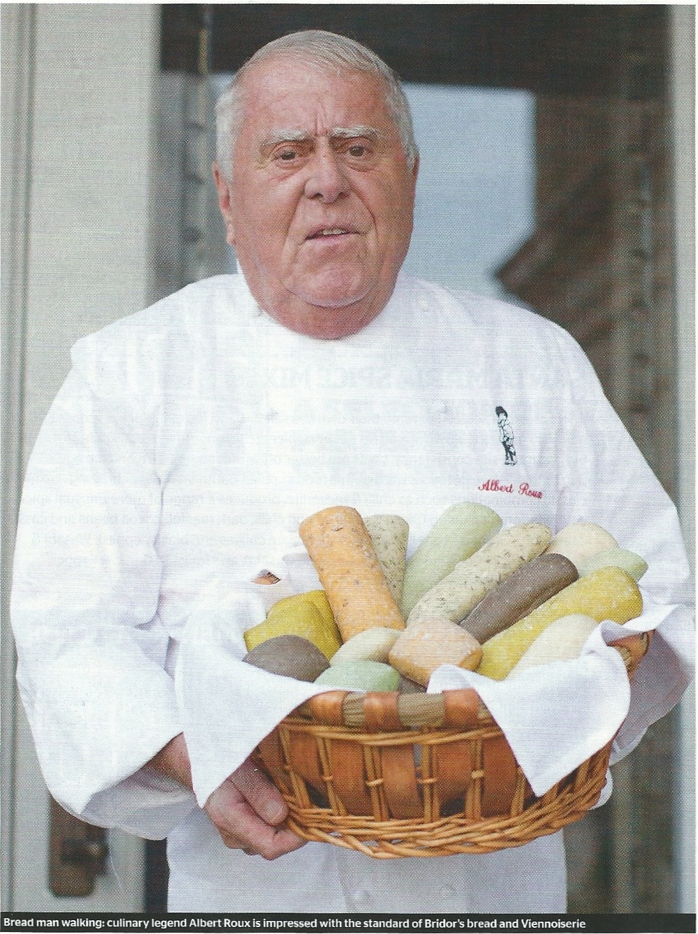

Introducing a new partnership between Albert Roux and Bridor

« I discovered Bridor many years ago when its Viennoiserie and breads were revolutionising the art of baking, owing to their quality and consistency.
I was invited to see the company’s factory in Brittany, and it was an explosion: I saw the care with which they selected their flours and the butter (beurre de Charentes), and everything smelled of quality. Amazing. But since then, Bridor hasn’t stood still. It has progressed.
Unlike some large companies, where products have decreased in quality as they have grown, it is the complete opposite for Bridor. As the company has grown, its products just get better and better.

Its newest collection is Arc En Ciel (« rainbow» in French ) range of breads, which I discovered at SIRHA (Salon International de la Restauration, de l’Hôtellerie et de l’Alimentation) in Lyon : it was love at first sight, and I knew then that I wanted to work in partnership with Bridor to develop ways with which to use the collection.
Tasty, naturally coloured and flavoured, Arc en Ciel bread extends the range of bakery products available to restaurants, caterers and event organisers. The crumb is delicate in texture.
The different flavours are Curry; Pickled Lemon with Thyme; Sun-dried Tomato; Nori (Japanese seaweed); Mint and Garlic; and Natural.

I love coloured cuisine from England as much as from abroad. This coloured and flavoured bread allows you to express how you feel about food because the basic product is wonderful: it’s pure and the flavour that emanates from it is absolutely fantastic. They allow me to create original finger-foods, snacks, creative dishes using flavoured breadcrumbs (as served at Le Gavroche), or simple and stylish colourful sandwiches for afternoon tea, which we serve very successfully at our hotels in Scotland.

To launch my partnership with Bridor and Arc En Ciel, not only have I developed a collection of afternoon tea sandwiches, but I have chosen to make coloured, modern, appetising recipes.
We’ve started with classical recipes, taking inspiration from Spain and Italy, as well as France, which will enhance¹ the flavour of the main component that goes into it.
By far the most popular sandwich served at our six hôtels in Scotland is smoked salmon. Conventionally, chefs use brown bread, but here I’ve used Arc En Ciel Nori flavoured bread for a sushi-style roll, which adds colour and flavour when paired with a good smoked salmon, rich avocado and a little heat from a wasabi-flavoured cream cheese.
This sandwich goes beautifully with a good Bourgogne Aligoté wine. Or, if serving for afternoon tea, the smokiness of Oolong tea pairs well. »

Restaurant magazine, December 2013

¹to enhance: souligner

