Is this the end of the rude Parisian waiter?

In an effort to make the rude French waiter stereotype a thing of the past, the Paris Tourist Board is launching a new etiquette guide.
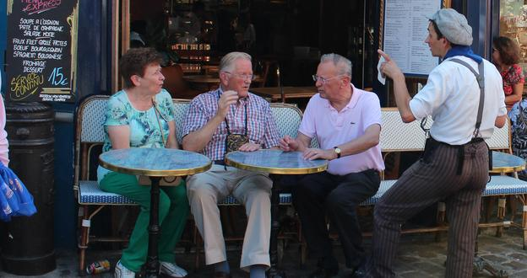
Paris has long been renowned for its unfriendly service. But in an effort to make the rude French waiter stereotype a thing of the past, the Paris Tourist Board is launching a new charm offensive.
As the world’s number one holiday destination (with 33 million international visitors a year) and half a million people working in tourism – that’s 9.5% of the region’s working population – Paris has good reason to nurture¹ its tourist industry. The etiquette guide Do You Speak Touriste? aimed at restaurants, hotels, shops and taxi drivers, is designed to make travellers feel more welcome in the City of Light.
The initiative, launched in June, includes an easy-to-use website and a printed guide featuring tips on how to treat the 10 main nationalities that visit the capital. For example, the guide recommends addressing Brits – the number one visitors to Paris – by their first name in a friendly manner. Americans expect to be spoken to in English; Germans desire cleanliness and precise information (as do the Japanese), while Italians are described as impatient travellers who are fond of excursions. The guide also includes helpful phrases, key statistics (such as trip length, average spend) and general information (including preferred meal times).
But just how accurate² is this country-specific advice?
“I'd agree with the points regarding friendly service but not the first name thing – I'd find that disconcerting!” said Londoner Malcolm Monteiro while visiting Paris for the weekend. According to the guide, visitors from Spain – the third most frequent visitors to the capital – expect to be spoken to in Spanish. Pere Solé from Barcelona, a regular visitor to the city, doesn’t agree but said more effort could be made by waiters when foreigners try to speak French.
“I know French requires good pronunciation to be understood but come on! Croissant, café... even with the worst Spanish accent you should be able to understand that!” he said somewhat exasperated. “Paris is one of the top tourist destinations in the world so anything that can help improve things in that area should be welcomed.”
Monteiro, however, was not as convinced, explaining that bad service is part of Paris’ charm. “I'm not sure Paris needs the guide to be honest. Levels of service are a cultural thing and don't need to be messed with.”
Kim Laidlaw, for BBC Travel, 20 September 2013
Adapted from http://www.bbc.com

¹nurture: prendre soin de
²accurate: correct

