**Ô SHAKESPEARE, SHAKESPEARE!**

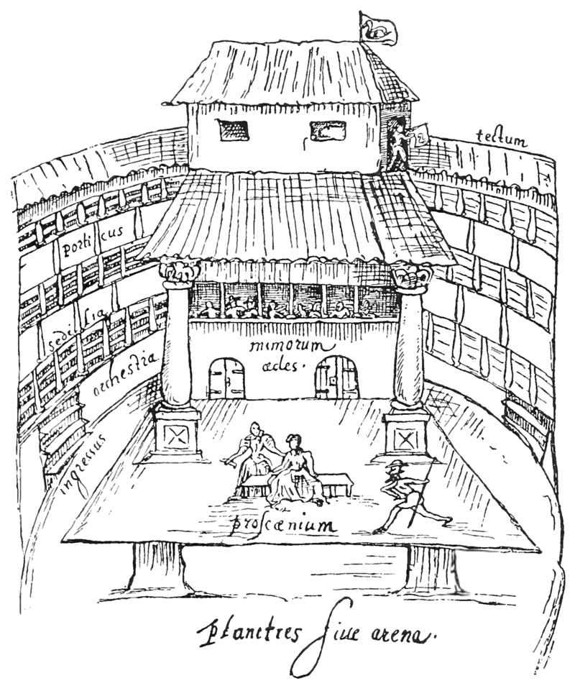

**THE THEATRE OF** [**ENGLAND**](https://en.wikipedia.org/wiki/England) **BETWEEN 1562 AND 1642.**

Sources : <https://en.wikipedia.org/wiki/English_Renaissance_theatre#/media/File:The_Swan_cropped.png>

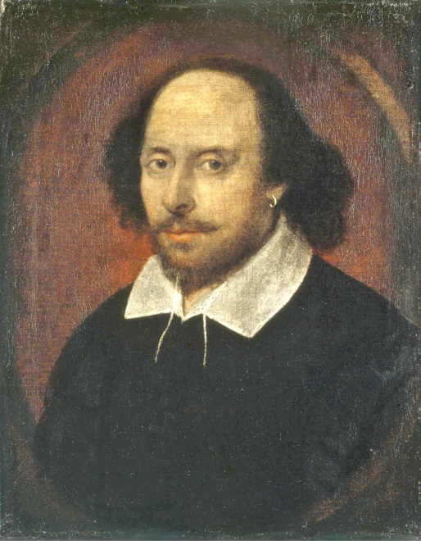

**WILLIAM SHAKESPEARE (1564-1616)**

Sources : <https://en.wikipedia.org/wiki/William_Shakespeare>

**Niveau visé :** B1 **A.L. dominante : EOC**

**Domaine :** Se cultiver et se divertir- (Monde et histoire des arts- Literature and theatre)

**Evaluation individuelle en E.O.C.**

**CECRL**

**PRODUCTION ORALE GÉNÉRALE**

**B1 :** Peut assez aisément mener à bien une description directe et non compliquée de sujets variés dans son domaine en la présentant comme une succession linéaire de points.

**A2 :** Peut décrire ou présenter simplement des gens, des conditions de vie, des activités quotidiennes, ce qu’on aime ou pas, par de courtes séries d’expressions ou de phrases non articulées.

**COMPORTEMENT PARALINGUISTIQUE**

• Langage du corps : expression du visage, posture, contact oculaire, proximité.

• Utilisation des traits prosodiques : qualité de la voix, ton.

**FINAL TASK**

You are going to set out a scenario about an impossible love such as in Romeo and Juliet, written by William Shakespeare. You will present us a tragic character and develop his characteristics. Then, you will highlight the idea of illusion.

|  |  |  |  |  |  |  |  |  |
| --- | --- | --- | --- | --- | --- | --- | --- | --- |
| **Séance** | **Support** | **AL** | **Objectif** | **Compétences linguistiques** | | | **Compétences culturelles** | **Compétences pragmatiques** |
| **Grammaire** | **Lexique** | **phonologie** |
| **1.**  **EXPOSITION OF ROMEO AND JULIET**  **(2h30)** | √ Trailer Romeo and Juliet, 1996  <https://www.youtube.com/watch?v=8JoOpx6VwHk>  √ Webquest  √ Game : who’s who? | EOC  CE/EE  EOC/EE | Raconter une histoire à travers la description de personnages.  **Écrits factuels à**  **dominante informative :** Trouver les informations pertinentes dans un document (*site* *internet*)  **Messages à**  **dominante informative**  **ou explicative :** présenter un personnage de pièce de théâtre. | Be going to  GN complexe-Génitif | Love at first sight-  To fall in love  Sad-tragic-tragedy-  Costume-prop | tra**g**edy | Pièce de théâtre : Roméo et Juliette, Shakespeare.  Exposition  Dramatis personae | Développement thématique |
| **2**  **TRAGIC CHARACTER**  **(2h)** | √ Extraits de scènes de théâtre  Romeo and Juliet | EOC | **Écrits à caractère**  **Littéraire :**  Lire et apprécier un extrait de pièce de théâtre  **Écrits à caractère**  **Littéraire :** Décrire un lieu, des personnes fictives | Have to  Stop+VING  Should | Stage,play, playwright, scene, act…  Conflicts,  Guilt | Both | Tragedy  Prologue-chorus | Aisance à l’oral  Précision |
| **3**  **(2h)**  **ALL THE WORLD’S STAGE** | √ As You Like It, Act 2, Scene 7 | IO | **Échanges à**  **dominante**  **argumentative**  Justifier sa position, réfuter celle de  son interlocuteur  Prendre une position et la défendre | Can-must | Agree with-disagree- | Intonation des phrases interrogatives | Determinism | Tours de parole |
| **5** | **EVALUATION ORALE EN EOC** | | | | | | | |

**WORD BOX:**

|  |  |
| --- | --- |
| **VERBS** | **NOUNS** |
| To write  To act  To play  To disguise  To rehearse | A genre  A play  A playwright  A stage  An act  A scene  A character  A comedian  A prop  A rehearsal |

**DOCUMENT D’ANTICIPATION** : Trailer of Romeo et Juliet, 1996

This is a modern adaptation of Romeo and Juliet, one of the most famous plays of Shakespeare.

  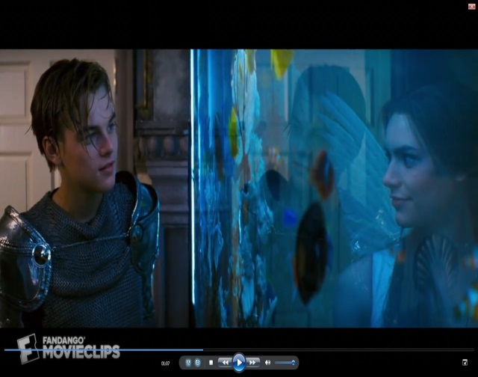

◊ **WHAT HAPPENS? LOOK AT THEIR EYES.**

**LISTEN TO THE MUSIC.**

◊ **WHAT’ S ABOUT THE RYTHM?**

◊ **HOW DO YOU FEEL?**

◊ **WHAT DOES IT PREDICT?**



**SÉANCE 1**

**exposition OF ROMEO AND JULIET**

**CE/EE**

**I/ LOVE: AN ETERNAL INSPIRATION**

The objective of the webquest is to make you understand the beginning of intrigue of Romeo and Juliet which is composed of 5 acts.

**ACT 1**

|  |  |
| --- | --- |
| **QUESTIONS** | **MAKE FULL SENTENCES** |
| **1/ Where does the scene take place?**  [www.veronafor2.com/verona.html](http://www.veronafor2.com/verona.html) (Look at **ROMEO & JULIET)**  Afficher l'image d'origine | **-------------------------------------------------------------**  **-------------------------------------------------------------**  **-------------------------------------------------------------** |
| **2/ What are the names of the families and what’s the link between them?**  [www.sparknotes.com/shakespeare/romeojuliet/summary.html](http://www.sparknotes.com/shakespeare/romeojuliet/summary.html) (1st lines of the 1st paragraph)  Afficher l'image d'origine | **-------------------------------------------------------------**  **-------------------------------------------------------------**  **-------------------------------------------------------------** |
| **3/ What does Prince of Verona symbolize? Justify your answer.**  [www.nosweatshakespeare.com/play-summary/romeo-juliet/](http://www.nosweatshakespeare.com/play-summary/romeo-juliet/) ( 1st paragraph) | **-------------------------------------------------------------**  **-------------------------------------------------------------** |
| **5/ What is Paris’s request?**  [www.shakespeare-navigators.com/romeo/Paris.html](http://www.shakespeare-navigators.com/romeo/Paris.html) (1st paragraph) | **-------------------------------------------------------------**  **-------------------------------------------------------------** |
| **4/ What happened during the feast organized by the Capulet family?**  [www.nosweatshakespeare.com/play-summary/romeo-juliet/](http://www.nosweatshakespeare.com/play-summary/romeo-juliet/) (2nd and 3rd paragraphs)  Afficher l'image d'origine | **-------------------------------------------------------------**  **-------------------------------------------------------------**  **-------------------------------------------------------------** |
| **5/ How can you qualify Romeo and Juliet’s love? React.**  [www.cliffsnotes.com/literature/r/romeo-and-juliet/summary-and-analysis/act-i-scene-5 (1](http://www.cliffsnotes.com/literature/r/romeo-and-juliet/summary-and-analysis/act-i-scene-5%20(1)st paragraph) | **-------------------------------------------------------------**  **-------------------------------------------------------------** |
| **6 / What does the nurse reveal to Romeo? React.**  [www.gradesaver.com/romeo-and-juliet/study-guide/summary](http://www.gradesaver.com/romeo-and-juliet/study-guide/summary) (4th paragraph) | **-------------------------------------------------------------**  **-------------------------------------------------------------** |

**II/ DRAMATIS PERSONAE**

**Rules of the game: Who’s Who in Romeo and Juliet?**

●The class will be composed of 2 groups. Each group has got 2 series of the presentation of the characters of Romeo and Juliet.

●In the middle of the class, there are 14 cards composed of the names and photos of the characters.

Your mission is to have more than 10 cards in your group.

1/ Read the presentation of each character in the first series.

2/ Your teacher will choose one character for group 1 and a different one for group 2. You’ve got 30 seconds to learn the presentation and send a representative of your team to say the whole sentence without reading. If it’s correct you can take it.

|  |  |  |
| --- | --- | --- |
| **GROUP 1**  2 SERIES OF PRESENTATIONS |  | **GROUP 2**  2 SERIES OF PRESENTATIONS |
| **ON THE TABLE**  14 CARDS WITH THE PHOTO AND NAMES OF THE CHARACTERS |
|  |

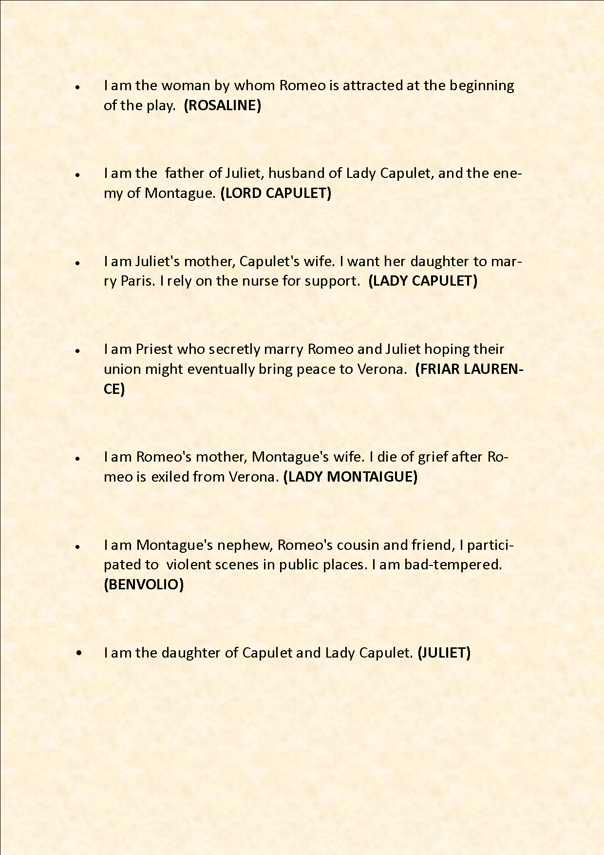 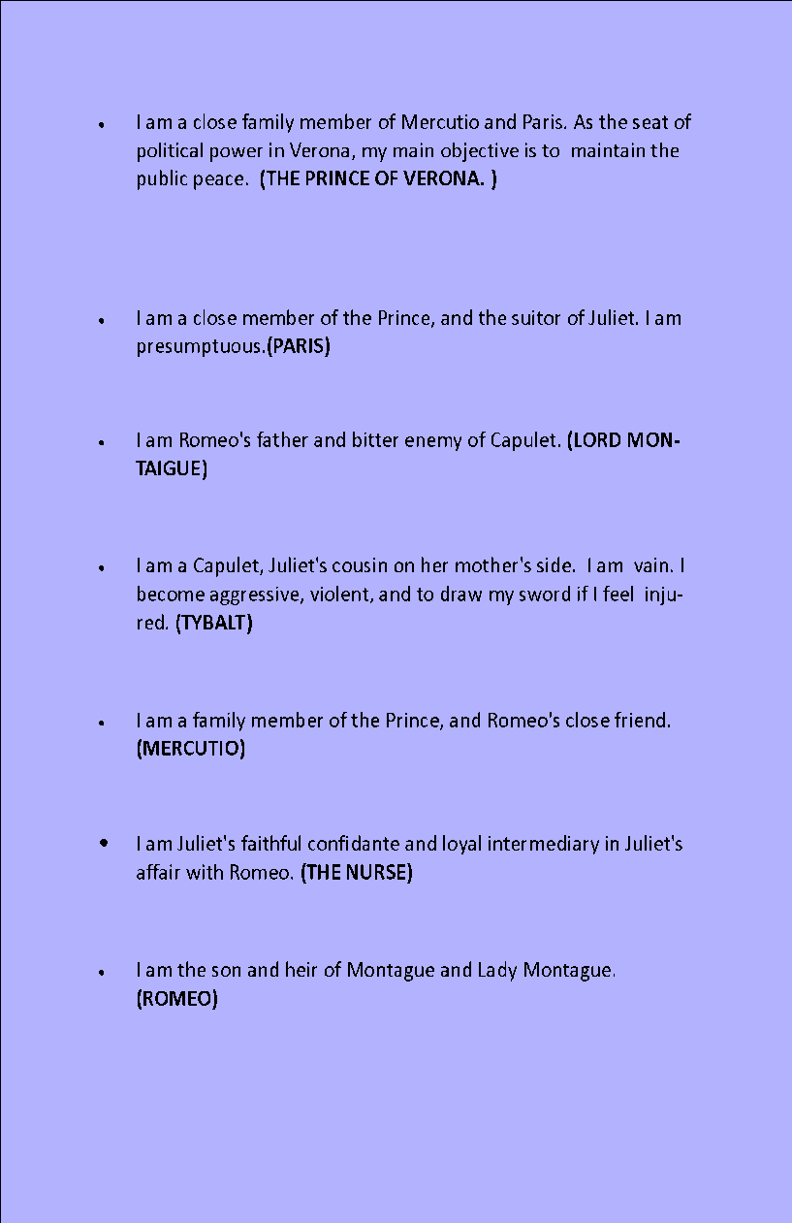

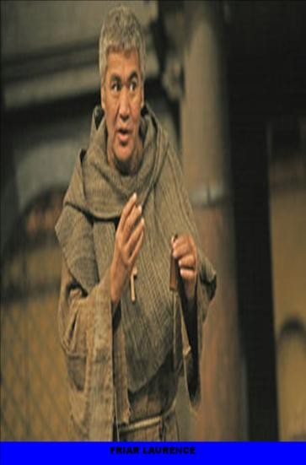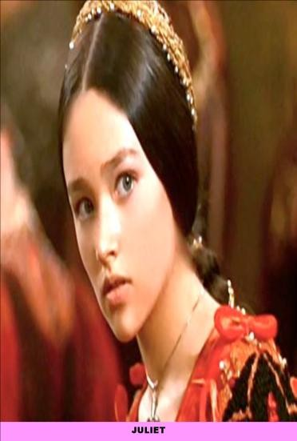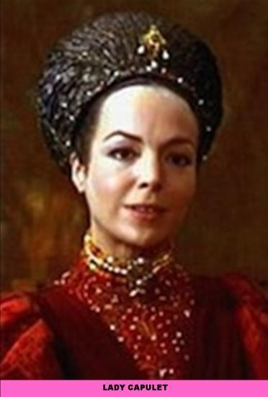

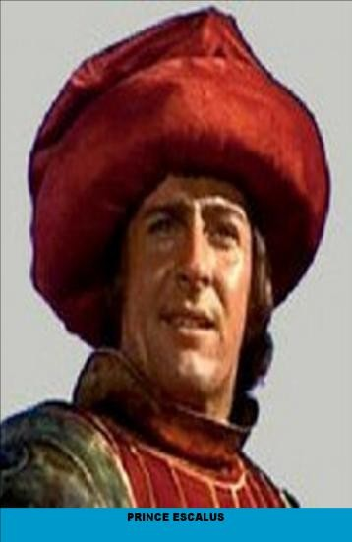

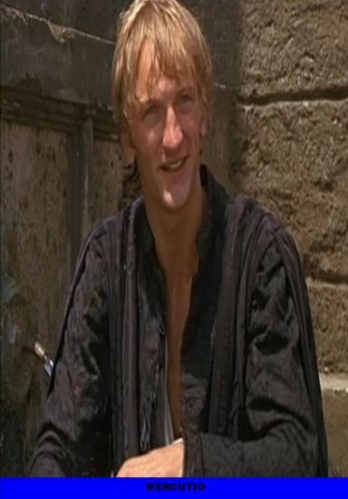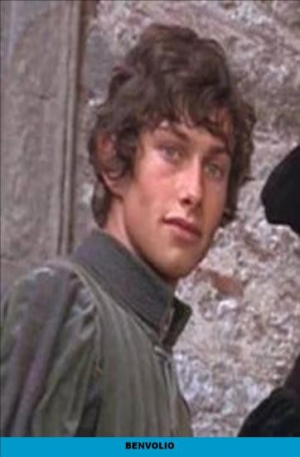

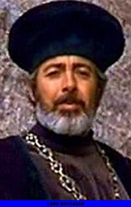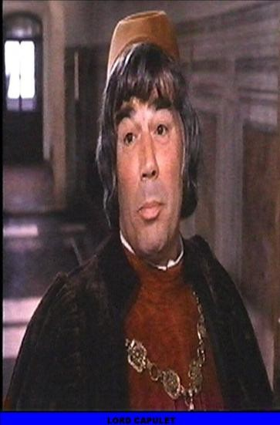

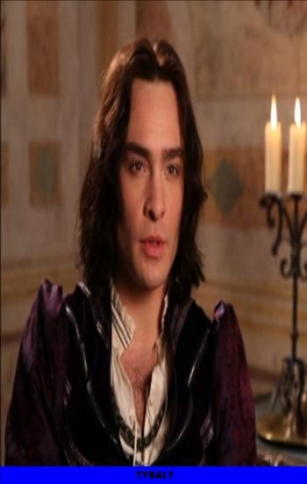

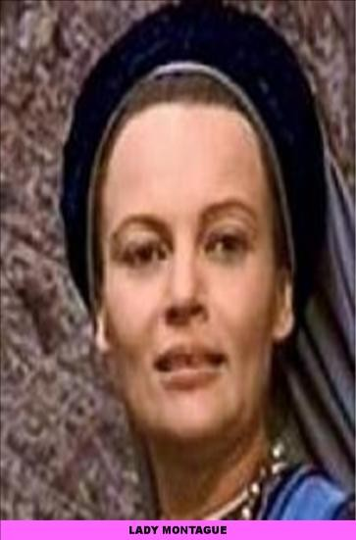

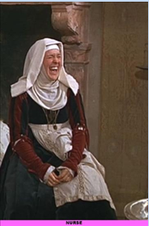

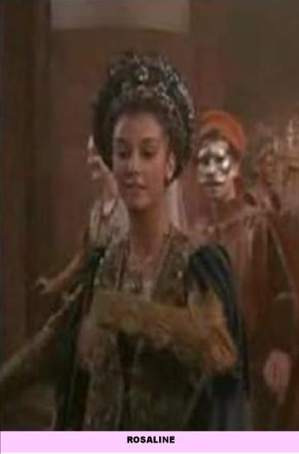 **SÉANCE 2 CE/EE**

**WHAT IS A TRAGIC CHARACTER**

**Etre capable de parler des conflits internes et externes qu’un personnage peut endurer.**

Thanks to your contribution, we will understand what tragedy is, in Romeo and Juliet, one of the most famous plays of Shakespeare.

The class will be composed of 4 groups.

•Each group will play a specific role and will work on a characteristic of a tragic character. (CE/EE)

•After, you will explain the work to the class thanks to a poster. (EOC) Use a PowerPoint.

**CONFLICTS BETWEEN MEN**

Prologue-Romeo and Juliet

**INNER CONFLICTS**

ACT 2, SCENE 2- Romeo and Juliet

**A HERO: GUILTY AND INNOCENT.**

Oedipus

**THE HERO: ACTIVE AND PASSIVE**

Oedipus

Organization of the classroom (20 pupils)

**GROUP 1: Prologue GROUP 2: Act 2, scene 2**

Dictionaries/

Internet

Dictionaries/

Internet

**GROUP 3: Oedipus GROUP 4: Oedipus**

Dictionaries/

Internet

Dictionaries/

Internet

Le professeur s’assurera de mettre dans le groupe 3 et 4 les personnes de la classe les plus en difficultés. Chaque groupe présentera sous forme de PowerPoint son travail (EOC). Ils auront un support papier et le format numérique afin de préparer au mieux leur travail. Chaque élève aura une fiche de synthèse de chaque groupe et pourra poser des questions au groupe.

You will have to read the text and answer the questions, making sentences.

**•1st group : CONFLICTS BETWEEN MEN**

**Prologue**

[**Chorus**](http://www.opensourceshakespeare.org/views/plays/characters/charlines.php?CharID=chorus-rj&WorkID=romeojuliet)**.** Two households[1], both alike in dignity,   
In fair[2] Verona, where we lay [3]our scene,   
From ancient grudge[4] break to new mutiny[5],   
Where civil blood makes civil hands unclean.   
From forth the fatal loins of these two foes[6]   
A pair of star-cross'd lovers take their life;   
Whose misadventured piteous overthrows   
Do with their death bury their parents' strife[7].   
The fearful passage of their death-mark'd love,   
And the continuance of their parents' rage,   
[…]

Sources : [www.opensourceshakespeare.org/views/plays/play_view.php?WorkID=romeojuliet&Act=0&Scope=act&pleasewait=1&msg=pl](http://www.opensourceshakespeare.org/views/plays/play_view.php?WorkID=romeojuliet&Act=0&Scope=act&pleasewait=1&msg=pl)

**1/ What is the function of the choral and prologue in theatre? Use a dictionary.**

**a) PROLOGUE**: -------------------------------------------------------------------------------------------------------

---------------------------------------------------------------------------------------------------------------------------

---------------------------------------------------------------------------------------------------------------------------

**b) CHORUS:** ----------------------------------------------------------------------------------------------------------

---------------------------------------------------------------------------------------------------------------------------

---------------------------------------------------------------------------------------------------------------------------

**2/ Where does the play take place?**

---------------------------------------------------------------------------------------------------------------------------

---------------------------------------------------------------------------------------------------------------------------

**3/ Speak about Romeo and Juliet and their families.**

|  |  |  |
| --- | --- | --- |
| **QUESTIONS** | **FAMILIES** | **ROMEO AND JULIET** |
| **NOUNS THAT QUALIFY THEM** | **-**  **-**  **-**  **-**  **-**  **-** | **-**  **-**  **-** |
| **EXPLAIN WHAT HAPPENS** |  |  |

**7/ Now make a synthesis to explain what happens in the prologue. Present us the external conflicts of Romeo and Juliet’s love. You can use a PowerPoint for your oral presentation.**

**•2ND GROUP: Inner conflicts**

**Act II, scene 2**

**JULIET** *(Not knowing* ROMEO *hears her)*

Oh, Romeo, Romeo,

Why do you **have to** be Romeo?

Forget about your father and change your name.

Or else, if you won’t change your name, just swear you love me and **I’ll stop being** a Capulet.

**ROMEO** *(To himself)*

**Should** I listen for more, or **should** I speak now?

**JULIET** *(Still not knowing* ROMEO *hears her)*

It’s only your name that’s my enemy. You’d still be yourself even if you **stopped being** a Montague. What’s a Montague anyway? It isn’t a hand, a foot, an arm, a face, or any other part of a man. Oh, be some other name! What does a name mean? The thing we call a rose would smell just as sweet if we called it by any other name. Romeo would be just as perfect even if he wasn’t called Romeo. Romeo, lose your name. Trade in your name—which really has nothing to do with you—and take all of me in exchange.

**ROMEO** *(To* JULIET*)*

I trust your words. Just call me your love, and I will take a new name. From now on I will never be Romeo again.

**JULIET**

Who are you? Why do you hide in the darkness and listen to my private thoughts?

Sources : <http://nfs.sparknotes.com/romeojuliet/page_80.html>

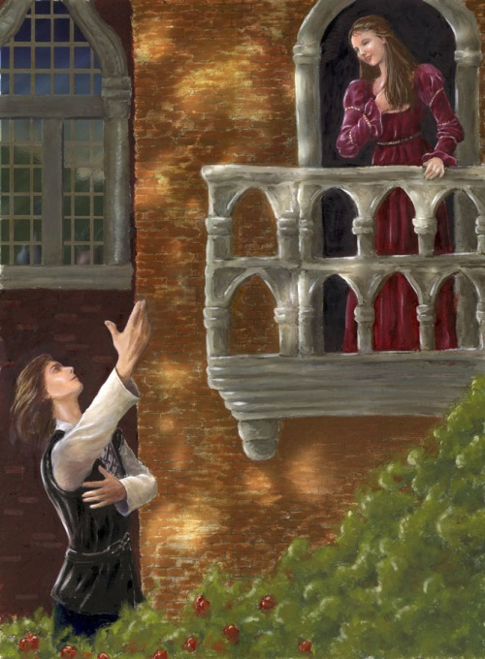

Sources : <https://englishosaca.wordpress.com/seventh-grade/romeo-and-juliet/>

**1/ What is the function of the stage directions? Use a dictionary. Explain what happens in this extract thanks to the stage direction.**

---------------------------------------------------------------------------------------------------------------------------

--------------------------------------------------------------------------------------------------------------------------------------

**2/ Give us the definition of apostrophe and examples chosen in this extract. You can use a dictionary.**

---------------------------------------------------------------------------------------------------------------------------

---------------------------------------------------------------------------------------------------------------------------

**3/ Say what Juliet would like Romeo to do and to be. (First play opposite)**

--------------------------------------------------------------------------------------------------------------------------------------

--------------------------------------------------------------------------------------------------------------------------------------

**4/ How does she consider his name? (Second play opposite)What’s your opinion?**

--------------------------------------------------------------------------------------------------------------------------------------

--------------------------------------------------------------------------------------------------------------------------------------

**5/ Do you think she shouldn’t be so tormented and stop loving him? Justify.**

--------------------------------------------------------------------------------------------------------------------------------------

--------------------------------------------------------------------------------------------------------------------------------------

**6/ Now make a synthesis to explain what happens in Act 2, scene 2 and how Juliet is confronted with her own inner conflicts. You can use a PowerPoint for your oral presentation.**

**•3rd group: A HERO: BOTH GUILTY AND INNOCENT**

Some Shakespearian characters are inspired by the tragedy of Oedipus.

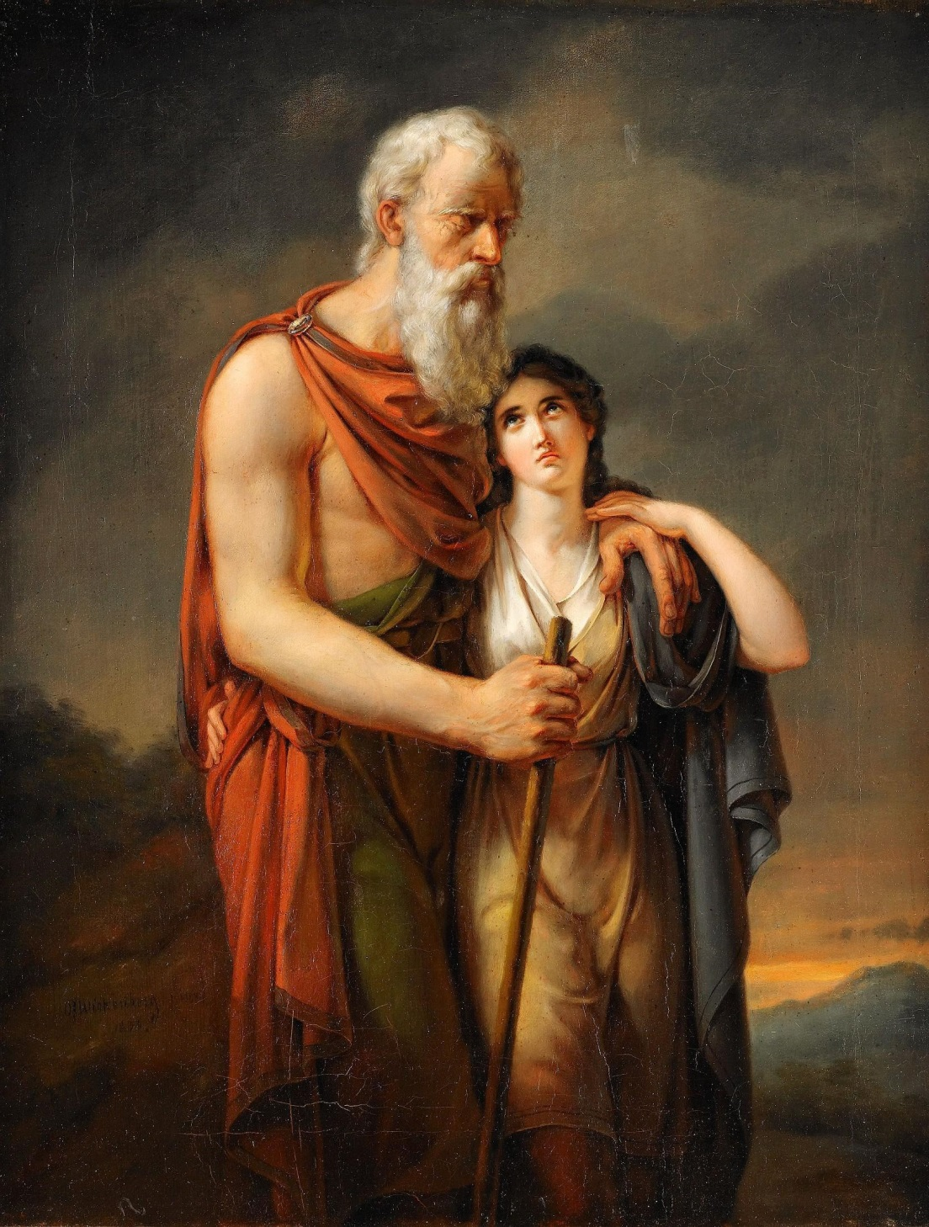

Sources : <https://commons.wikimedia.org/wiki/File:Per_Gabriel_Wickenberg_-_Oedipus_och_Antigone.jpg>

**OEDIPUS**

1. Oedipus was a king in Greek mythology, ruling over the city of [Thebes](http://www.greekmythology.com/Myths/Places/Thebes/thebes.html). He was the son of King [Laius](http://www.greekmythology.com/Myths/Mortals/Laius/laius.html) and Queen [Jocasta](http://www.greekmythology.com/Myths/Mortals/Jocasta/jocasta.html). Not knowing, he married his mother and had four children with her, [Polynices](http://www.greekmythology.com/Myths/Mortals/Polynices/polynices.html), [Eteocles](http://www.greekmythology.com/Myths/Mortals/Eteocles/eteocles.html), [Antigone](http://www.greekmythology.com/Myths/Mortals/Antigone/antigone.html), and [Ismene](http://www.greekmythology.com/Myths/Mortals/Ismene/ismene.html).
2. It all started when King [Laius](http://www.greekmythology.com/Myths/Mortals/Laius/laius.html) decided to consult the Oracle at [Delphi](http://www.greekmythology.com/Myths/Places/Delphi/delphi.html) to learn if he and his wife would ever have children. The prophecy given was that any son that was born out of their union would kill them. **[…]**. To avoid the prophecy, **[…]** [Jocasta](http://www.greekmythology.com/Myths/Mortals/Jocasta/jocasta.html) then gave (Oedipus) to one of their shepherds, telling him to leave the baby in the mountains to die. The shepherd, **[…]** brought it at the court of King Polybus and Queen Merope of [Corinth](http://www.greekmythology.com/Myths/Places/Corinth/corinth.html).
3. […] When [Oedipus](http://www.greekmythology.com/Myths/Mortals/Oedipus/oedipus.html) grew up, he was told by someone that Polybus and Merope were not his real parents. Deciding to investigate this matter, [Oedipus](http://www.greekmythology.com/Myths/Mortals/Oedipus/oedipus.html) ended up in [Delphi](http://www.greekmythology.com/Myths/Places/Delphi/delphi.html), to consult the Oracle. There, he was told that he would kill his father and marry his mother. Upon hearing this, [Oedipus](http://www.greekmythology.com/Myths/Mortals/Oedipus/oedipus.html) thought that the prophecy meant Polybus and Merope, and decided not to return to [Corinth](http://www.greekmythology.com/Myths/Places/Corinth/corinth.html). Instead, he started walking towards the city of [Thebes](http://www.greekmythology.com/Myths/Places/Thebes/thebes.html).
4. On his way there, he came across King [Laius](http://www.greekmythology.com/Myths/Mortals/Laius/laius.html), his biological father, on a chariot, as he was on his way to the Oracle once again. [Oedipus](http://www.greekmythology.com/Myths/Mortals/Oedipus/oedipus.html) and [Laius](http://www.greekmythology.com/Myths/Mortals/Laius/laius.html)' charioteer started quarreling over who had the right of way. The quarrel ended up with [Oedipus](http://www.greekmythology.com/Myths/Mortals/Oedipus/oedipus.html) killing the charioteer and his father, thus unknowingly fulfilling the first half of his prophecy.[…]
5. When [Oedipus](http://www.greekmythology.com/Myths/Mortals/Oedipus/oedipus.html) reached [Thebes](http://www.greekmythology.com/Myths/Places/Thebes/thebes.html), he was accepted with honours by [Creon](http://www.greekmythology.com/Myths/Mortals/Creon/creon.html), [Jocasta](http://www.greekmythology.com/Myths/Mortals/Jocasta/jocasta.html)'s brother and his uncle, who served as a temporary king after [Laius](http://www.greekmythology.com/Myths/Mortals/Laius/laius.html)' death. [Creon](http://www.greekmythology.com/Myths/Mortals/Creon/creon.html) had said that anyone who would kill the [Sphinx](http://www.greekmythology.com/Myths/Monsters/Sphinx/sphinx.html) would become king and would marry [Jocasta](http://www.greekmythology.com/Myths/Mortals/Jocasta/jocasta.html). Thus, the second part of the prophecy was fulfilled and [Oedipus](http://www.greekmythology.com/Myths/Mortals/Oedipus/oedipus.html) rose to the throne of [Thebes](http://www.greekmythology.com/Myths/Places/Thebes/thebes.html), marrying his mother. […]
6. [Oedipus](http://www.greekmythology.com/Myths/Mortals/Oedipus/oedipus.html) sent [Creon](http://www.greekmythology.com/Myths/Mortals/Creon/creon.html) to the Oracle at [Delphi](http://www.greekmythology.com/Myths/Places/Delphi/delphi.html) to get a consultation. [Creon](http://www.greekmythology.com/Myths/Mortals/Creon/creon.html) learned that it all happened because the killer of [Laius](http://www.greekmythology.com/Myths/Mortals/Laius/laius.html) had not been taken to justice. [Oedipus](http://www.greekmythology.com/Myths/Mortals/Oedipus/oedipus.html) cursed the killer of [Laius](http://www.greekmythology.com/Myths/Mortals/Laius/laius.html), and asked the prophet [Tiresias](http://www.greekmythology.com/Myths/Figures/Teiresias/teiresias.html) to find out who the killer was. [Tiresias](http://www.greekmythology.com/Myths/Figures/Teiresias/teiresias.html) was forced to say that it was [Oedipus](http://www.greekmythology.com/Myths/Mortals/Oedipus/oedipus.html) who killed the former king, and that he also did not know who his true parents were. […]

Adapter from [www.greekmythology.com/Myths/Mortals/Oedipus/oedipus.html](http://www.greekmythology.com/Myths/Mortals/Oedipus/oedipus.html)

**I/ ENLIGHTEN US!**

*Look at paragraphs 1 and 2*

**BIOLOGICAL PARENTS ADOPTIVE PARENTS**

OEDPIUS

OEDIPUS

**II/ CHARACTERS: ARE THEY THEIR OWN MASTERS?**

**Complete the following chart.**

1/ How can you define an oracle?

2/ What did the prophecy say to the parents of Oedipus?

|  |  |
| --- | --- |
|  | **THE PARENTS OF OEDIPUS** |
| **What did the Oracle say?** | Paragraph 2  ----------------------------------------------------------------------------------------  ---------------------------------------------------------------------------------------- |
| **What do they do to avoid the prophecy** | Paragraph 2  ----------------------------------------------------------------------------------------  ----------------------------------------------------------------------------------------  ----------------------------------------------------------------------------------------  ---------------------------------------------------------------------------------------- |
| **What happens?** | ----------------------------------------------------------------------------------------  ---------------------------------------------------------------------------------------- |

**III/ DO YOU THINK OEDIPUS IS BOTH INNOCENT AND GUILTY? JUSTIFY.**

---------------------------------------------------------------------------------------------------------------------

---------------------------------------------------------------------------------------------------------------------

---------------------------------------------------------------------------------------------------------------------

**IV/ Now make a synthesis to explain what happens and how Oedipus is both an innocent and guilty character. You can use a PowerPoint for your oral presentation.**

**4TH GROUP: A HERO WHO IS BOTH PASSIVE AND ACTIVE**

Some Shakespearian characters are inspired by the story of Oedipus.

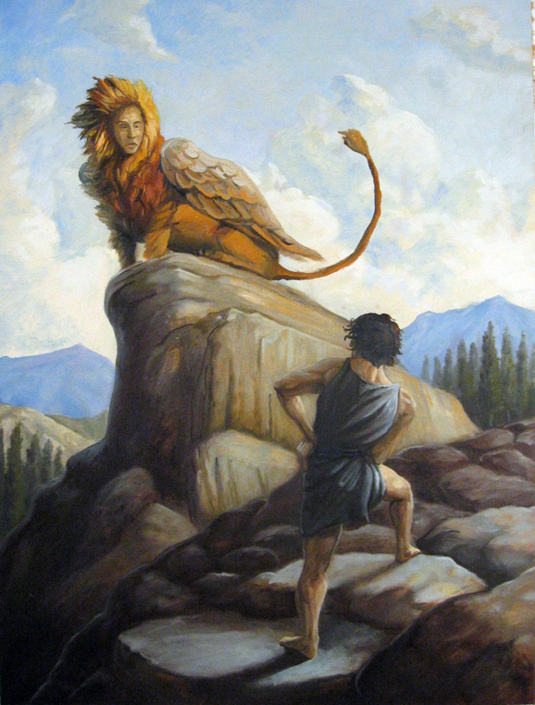

Sources : [www.greekmythology.com/Myths/Mortals/Oedipus/oedipus.html](http://www.greekmythology.com/Myths/Mortals/Oedipus/oedipus.html)

**OEDIPUS**

1. Oedipus was a king in Greek mythology, ruling over the city of [Thebes](http://www.greekmythology.com/Myths/Places/Thebes/thebes.html). He was the son of King [Laius](http://www.greekmythology.com/Myths/Mortals/Laius/laius.html) and Queen [Jocasta](http://www.greekmythology.com/Myths/Mortals/Jocasta/jocasta.html). Not knowing, he married his mother and had four children with her, [Polynices](http://www.greekmythology.com/Myths/Mortals/Polynices/polynices.html), [Eteocles](http://www.greekmythology.com/Myths/Mortals/Eteocles/eteocles.html), [Antigone](http://www.greekmythology.com/Myths/Mortals/Antigone/antigone.html), and [Ismene](http://www.greekmythology.com/Myths/Mortals/Ismene/ismene.html).
2. It all started when King [Laius](http://www.greekmythology.com/Myths/Mortals/Laius/laius.html) decided to consult the Oracle at [Delphi](http://www.greekmythology.com/Myths/Places/Delphi/delphi.html) to learn if he and his wife would ever have children. The prophecy given was that any son that was born out of their union would kill them. **[…]**. To avoid the prophecy, **[…]** [Jocasta](http://www.greekmythology.com/Myths/Mortals/Jocasta/jocasta.html) then gave (Oedipus) to one of their shepherds, telling him to leave the baby in the mountains to die. The shepherd, **[…]** brought it at the court of King Polybus and Queen Merope of [Corinth](http://www.greekmythology.com/Myths/Places/Corinth/corinth.html).
3. […] When [Oedipus](http://www.greekmythology.com/Myths/Mortals/Oedipus/oedipus.html) grew up, he was told by someone that Polybus and Merope were not his real parents. Deciding to investigate this matter, [Oedipus](http://www.greekmythology.com/Myths/Mortals/Oedipus/oedipus.html) ended up in [Delphi](http://www.greekmythology.com/Myths/Places/Delphi/delphi.html), to consult the Oracle. There, he was told that he would kill his father and marry his mother. Upon hearing this, [Oedipus](http://www.greekmythology.com/Myths/Mortals/Oedipus/oedipus.html) thought that the prophecy meant Polybus and Merope, and decided not to return to [Corinth](http://www.greekmythology.com/Myths/Places/Corinth/corinth.html). Instead, he started walking towards the city of [Thebes](http://www.greekmythology.com/Myths/Places/Thebes/thebes.html).
4. On his way there, he came across King [Laius](http://www.greekmythology.com/Myths/Mortals/Laius/laius.html), his biological father, on a chariot, as he was on his way to the Oracle once again. [Oedipus](http://www.greekmythology.com/Myths/Mortals/Oedipus/oedipus.html) and [Laius](http://www.greekmythology.com/Myths/Mortals/Laius/laius.html)' charioteer started quarreling over who had the right of way. The quarrel ended up with [Oedipus](http://www.greekmythology.com/Myths/Mortals/Oedipus/oedipus.html) killing the charioteer and his father, thus unknowingly fulfilling the first half of his prophecy.[…]
5. When [Oedipus](http://www.greekmythology.com/Myths/Mortals/Oedipus/oedipus.html) reached [Thebes](http://www.greekmythology.com/Myths/Places/Thebes/thebes.html), he was accepted with honours by [Creon](http://www.greekmythology.com/Myths/Mortals/Creon/creon.html), [Jocasta](http://www.greekmythology.com/Myths/Mortals/Jocasta/jocasta.html)'s brother and his uncle, who served as a temporary king after [Laius](http://www.greekmythology.com/Myths/Mortals/Laius/laius.html)' death. [Creon](http://www.greekmythology.com/Myths/Mortals/Creon/creon.html) had said that anyone who would kill the [Sphinx](http://www.greekmythology.com/Myths/Monsters/Sphinx/sphinx.html) would become king and would marry [Jocasta](http://www.greekmythology.com/Myths/Mortals/Jocasta/jocasta.html). Thus, the second part of the prophecy was fulfilled and [Oedipus](http://www.greekmythology.com/Myths/Mortals/Oedipus/oedipus.html) rose to the throne of [Thebes](http://www.greekmythology.com/Myths/Places/Thebes/thebes.html), marrying his mother. […]
6. [Oedipus](http://www.greekmythology.com/Myths/Mortals/Oedipus/oedipus.html) sent [Creon](http://www.greekmythology.com/Myths/Mortals/Creon/creon.html) to the Oracle at [Delphi](http://www.greekmythology.com/Myths/Places/Delphi/delphi.html) to get a consultation. [Creon](http://www.greekmythology.com/Myths/Mortals/Creon/creon.html) learned that it all happened because the killer of [Laius](http://www.greekmythology.com/Myths/Mortals/Laius/laius.html) had not been taken to justice. [Oedipus](http://www.greekmythology.com/Myths/Mortals/Oedipus/oedipus.html) cursed the killer of [Laius](http://www.greekmythology.com/Myths/Mortals/Laius/laius.html), and asked the prophet [Tiresias](http://www.greekmythology.com/Myths/Figures/Teiresias/teiresias.html) to find out who the killer was. [Tiresias](http://www.greekmythology.com/Myths/Figures/Teiresias/teiresias.html) was forced to say that it was [Oedipus](http://www.greekmythology.com/Myths/Mortals/Oedipus/oedipus.html) who killed the former king, and that he also did not know who his true parents were. […]

Adapter from [www.greekmythology.com/Myths/Mortals/Oedipus/oedipus.html](http://www.greekmythology.com/Myths/Mortals/Oedipus/oedipus.html)

**I/ WHAT A TRAGEDY!**

*Look at paragraphs 1*

**OEDIPUS’S FAMILY**

OEDIPUS

**II/ CHARACTERS: ARE THEY THEIR OWN MASTERS?**

**Complete the following chart.**

1/ How can you define an oracle?

2/ What did the prophecy reveal to Oedipus and his parents?

|  |  |
| --- | --- |
|  | **OEDIPUS** |
| **What did the Oracle say?** | Paragraph 3 and 6  ----------------------------------------------------------------------------------------  ---------------------------------------------------------------------------------------- |
| **What does he do to avoid the prophecy** | Paragraph 3  ----------------------------------------------------------------------------------------  ----------------------------------------------------------------------------------------  ----------------------------------------------------------------------------------------  ---------------------------------------------------------------------------------------- |
| **What happens?** | ----------------------------------------------------------------------------------------  ---------------------------------------------------------------------------------------- |

**III/ HOW IS OEDIPUS BOTH PASSIVE AND ACTIVE IN HIS LIFE? JUSTIFY.**

---------------------------------------------------------------------------------------------------------------------

---------------------------------------------------------------------------------------------------------------------

---------------------------------------------------------------------------------------------------------------------

**IV/ Now make a synthesis to explain what happens and how Oedipus is both an active and a passive character. You can use a PowerPoint for your oral presentation.**

**SEANCE 2 IO**

**ALL THE WORLD’S STAGE!**

**Etre capable de débattre sur les rapports humains.**

**Comprendre ce qu’est le déterminisme.**

**AS YOU LIKE IT, ACT 2, SCENE 7**

**JAQUES**

All the world's a stage,  
And all the men and women merely players:  
They have their exits and their entrances;  
And one man in his time plays many parts,  
His acts being seven ages.

Sources : <http://shakespeare.mit.edu/asyoulikeit/asyoulikeit.2.7.html>

**LET’S DEBATE!**

**1) Read and interpret this extract. You can use a dictionary.**

**2) Do you think the world is a stage? (Examples: marriage, work, truth, friends…)**

a) Share your ideas with your partners

b) Prepare questions for the other group to contradict them

|  |  |
| --- | --- |
| **GROUP 1**  **PRO** | **GROUP 2**  **CONS** |
|  |  |

**GRILLE D’EVALUATION EOC**

|  |  |
| --- | --- |
| **1/DRAMATIS PERSONAE** | **/2.5** |
| a) Présenter le personnage principal (Prénom, Nom, âge, statut social) 1 phrase  b) Citer au moins 5 personnages clés de la pièce de théâtre (lien de parenté, amis, employés) | /1.5  /1 |
| **2/ CHORUS** | **/3.5** |
| a) Présenter le lieu (situation économique ou politique, situation géographique) 1 phrase  b) Parler de l’action dramatique 2 phrases  c) Dire le thème de l’histoire 1 phrase | /1  /1.5  /1 |
| **3/ PERSONNAGE TRAGIQUE CREE** | **/10** |
| a) Conflits intérieurs : comment le personnage vit son histoire (tourments…) 2 phrases  b) Conflits extérieurs : conflits entre la famille du bien aimé et du personnage principal  2 phrases  c) Le personnage est acteur de sa vie 2 phrases  d) Le personnage subit la vie malgré lui 2 phrases  e) Le personnage : à la fois innocent et coupable. 2 phrases | /2  /2  /2  /2  /2 |
| **4/ L’ILLUSION** | **/4** |
| a) Dire que son personnage est amené à jouer un rôle 2 phrases  b) Argumenter 2 phrases | /2  /2 |

1. famlies
2. beautiful
3. There is
4. rancune
5. rixe
6. enemies
7. animosity