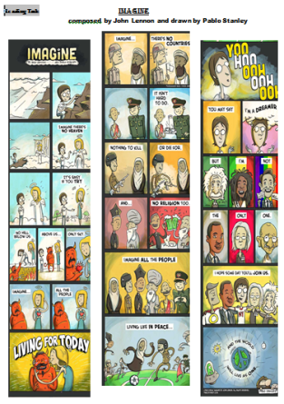
CE – Mise en œuvre “Imagine”

8” - Classe en groupes de 4 ou 5 élèves
Get the pupils to cut the pictures out, get the pupils to move into groups of 4 then put the cards back in order (so that they start a kind of debate).

20” - Pick out the different people:
3 categories: celebrities + other people + symbols

Celebrities: (= si certains personnages sont pas reconnus par les élèves, préparer des petits papiers avec les noms et leur faire piocher mais les laisser commencer par ceux qu'ils connaissent ou reconnaissent)
Get the pupils to complete the grid on board

- John Lennon: English singer-songwriter / member of the rock band the Beatles / wrote several iconic songs such as “Imagine” or “Give Peace a Chance” / rebellious nature / peace activist / was murdered
- Albert Einstein: German-born physicist / best known for his mass-energy equivalence formula E = mc2 / Nobel Prize winner / fought for a peaceful world, especially in times of war
- Bob Marley: Jamaican reggae singer-songwriter / sense of spirituality / received the Peace Medal of the Third World from the United Nations (= an award given to those who helped fight for justice and peace in third world countries) / peace activist / opposed to oppressive authorities
- Harvey Milk: American politician from San Francisco / the first openly gay person to be elected to public office in California / was assassinated / became an icon and a martyr in the gay community / was posthumously awarded the Presidential Medal of Freedom in 2009
- Martin Luther King: American pastor and activist / leader in the African-American Civil Rights Movement / best known for using nonviolent civil disobedience / Nobel Peace Prize winner / assassinated in Memphis
- Anna Politkovskaya: Russian journalist / human rights activist / best known for her opposition to Vladimir Putin / was murdered in 2006 / received the Amnesty International Global Award for Human Rights Journalism
- Mahatma Gandhi: Indian leader of the independence movement / used nonviolent civil disobedience / inspired freedom across the world / was assassinated / best example of peace worldwide

Pour permettre aux élèves faire de la PPC à partir des célébrités identifiées, écrire sous forme de notes la biographie de chaque personnage sur des morceaux de papier et leur faire piocher un papier.

Other people:
- Ethnic groups: Africans + Asians + Europeans
- Religious groups: Buddhists + Catholics + Jews + Muslims

Symbols:
- Angels + Devils

5” - Find out the elements that unit:
- Peace + Love + equality

5” - Find out the elements that divide:
- Lack of tolerance + mental and geographical frontiers/borders/boundaries

10” - Work on the implicit…
- Title: “Imagine” -– Dream v. Reality + Utopia v. Dystopia (= a society characterized by human misery, squalor, oppression, disease and overcrowding)
- What is important to these artists (Lennon and Stanley)? –- Freedom of expression + Freedom of thoughts
- Cultural aspect –- Reinterpretation / Rewriting of a famous song + Call for a better world, a boundless world

