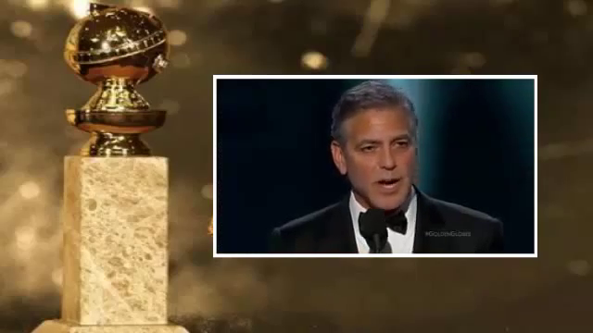

« And just one last thing I would say is, just to reiterate what we’ve all been talking about, yesterday was an extraordinary day, there were millions of people that marched, not just in Paris, but around the world. They were Christians and Jews and Muslims. There were leaders of countries all over the world. They didn’t march in protest, they marched in support of the idea that we will not walk in fear, and we won’t do it. So,
Je suis Charlie »

http://www.youtube.com/watch?v=7QEFV0YQwnA

