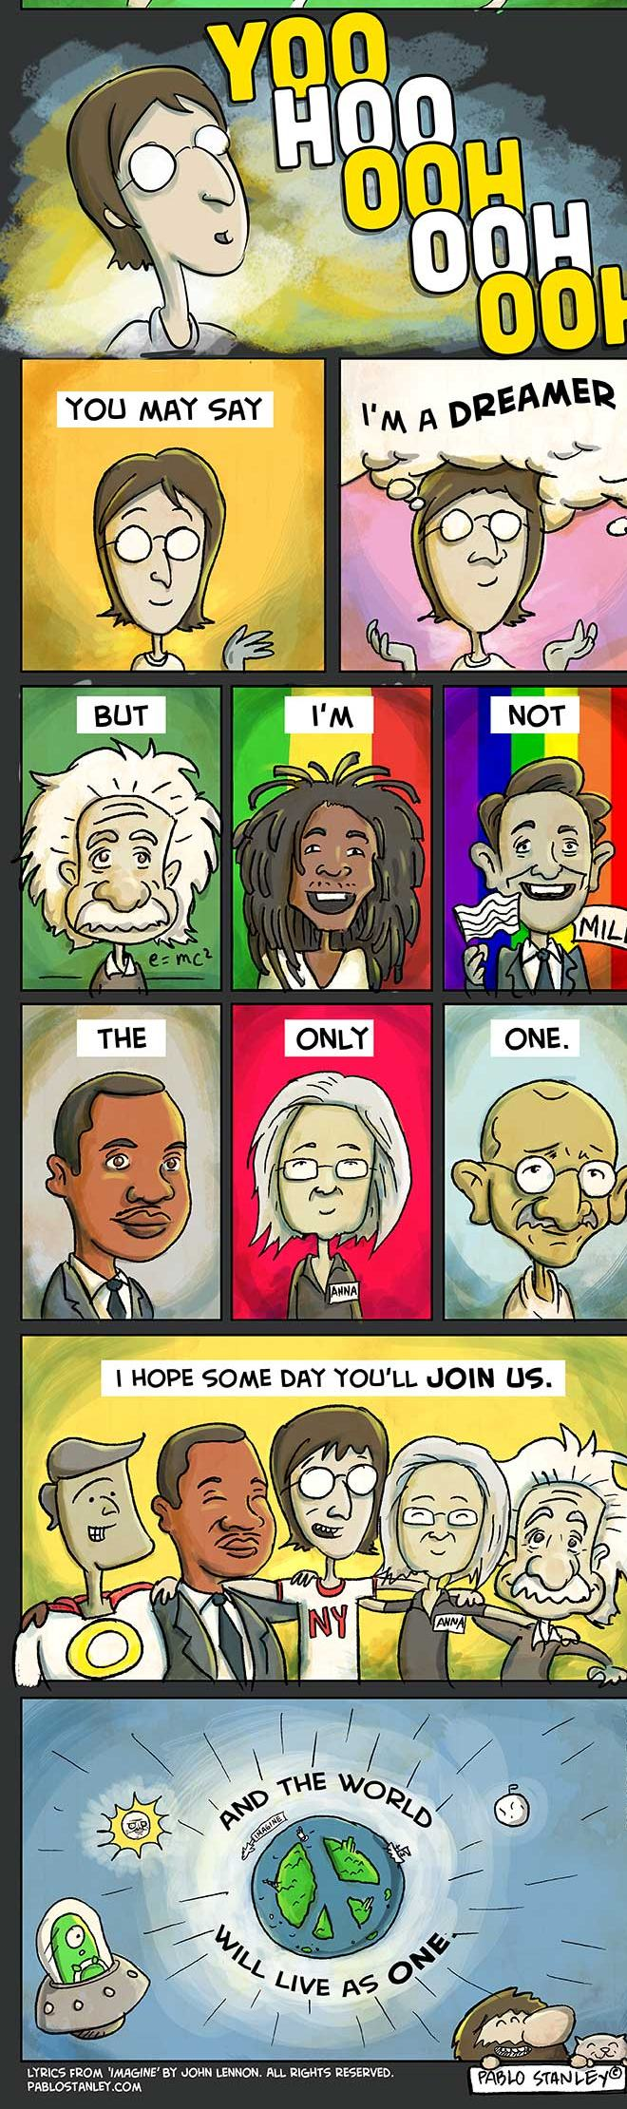
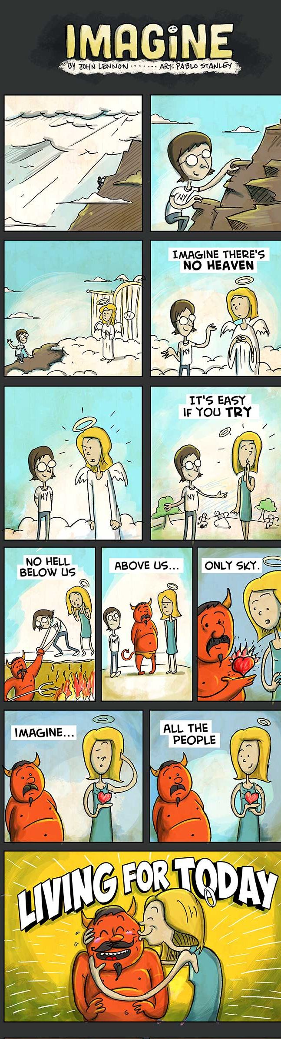
Reading Task Imagine
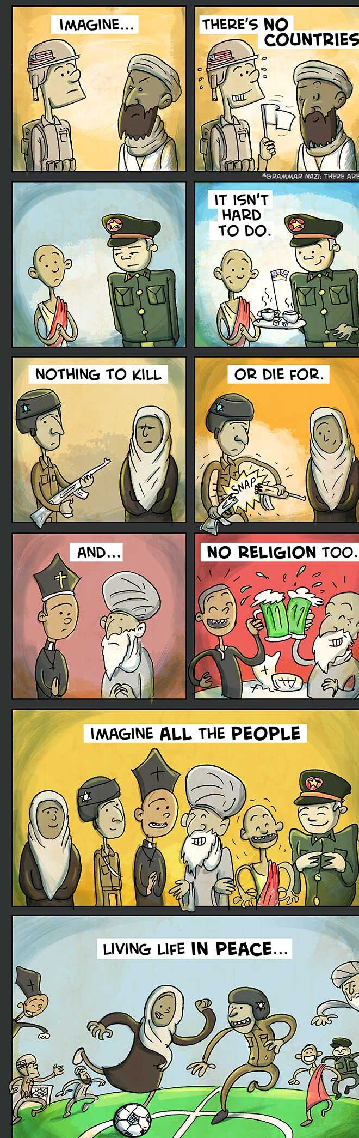
composed by John Lennon and drawn by Pablo Stanley

