How to Find Your First Job
Whether you're a teen or older and looking for your first job, you'll need to prepare for a job search. Before you start looking for your first job, you will need to gather some information together including details and dates of your educational background, as well as your skills, and any volunteer or informal work experience you have.
How to Apply for a First Job
If you are applying in-person for your first job, here's what to wear, what to bring, and the details that you need to know before you start applying.
Be Persistent. Wait a few days, then follow-up your application with a phone call to the hiring manager reiterating your interest. If you have applied in person, stop in again and mention that you are really interested in the opportunity.
Don't Stop. Don't apply at one place and wait for the phone to ring. Complete as many job applications as you can, and consider a variety of positions. The more you apply the better chance you have of finding a job.
Be Flexible. Applicants who are only available for limited hours are less likely to get hired than those who are flexible as to when they can work.
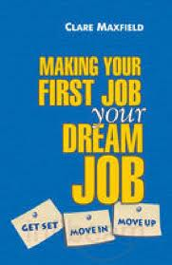
Use Your Connections. If you have a connection, use it. Does your mum shop regularly at the store where you'd like to work? If so, have her mention that you're looking for a job. That's how I got my first job and how my brother got his first job at the drug store across the street.
Dress Appropriately. When applying for jobs, dress as though you had the job. If you're applying for a retail position, for example, visit the store before you apply to see what the staff is wearing. It will give you an idea as to how you should dress. When in doubt, dress up, not down.
Don't Give Up. Job searching isn't easy, especially when you don't have much experience or many skills. Keep trying and keep applying and you will find a job. Your first job will be a stepping stone* to your next job - and to your future career.

http://jobsearch.about.com/od/teenstudentgrad

*A stepping stone: un tremplin

