The Gastronomic Meal of the French: A Great Tradition

UNESCO has decided to list the Gastronomic Meal of the French as Intangible Cultural Heritage. It is based on the idea that this meal is a real social practice and contributes to the transmission of the French heritage.

A meal is not just about eating. This could be a French motto. Indeed, 95.2% of French people think a gastronomic meal is part of their identity and their cultural background. In 2010, The Gastronomic Meal of The French was listed as Intangible Cultural Heritage of Humanity by UNESCO.

Today, 98.7% of French people believe the gastronomic meal has to be saved and passed to future generations. It is considered a ritual which helps celebrate the important moments of life. Beyond the food, what really matters in a meal is the social practice around it : the conviviality, the pleasure of taste, the sharing, the association of wine and food... As a festive moment with friends and family, the French Gastronomic meal is more than anywhere else a social time at fixed hours. At 12:30 pm, more than 54% of French people are sitting at a table eating. In comparison, in Great-Britain, the equivalent is 1:10 pm and only 17% of the population is seated at a table eating. In France at least one meal a day is spent with family.

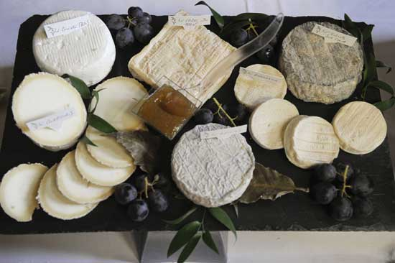
The French gastronomic meal is also characterized by the time spent at the table, the order of the courses : aperitif, starter, fish or meat with vegetable, cheese, dessert and digestive. Also the pleasure of setting a beautiful table and of course the cooking of home-made food.

The preservation of this meal and its values is one of the goals of a broader French food policy (PNA, Programme National pour l’Alimentation). Throughout this program, different ministries organize concrete actions to promote products, skills and gastronomic tourism and to teach schoolchildren about all these values. It therefore seemed logical to apply for this recognition of Intangible Cultural Heritage, even though it was the first time that UNESCO so recognized a food habit.

http://www.frenchfoodintheus.org/spip.php?article3004
Published on December 15, 2011

Motto = devise ; slogan

