CULTURE SHOCK
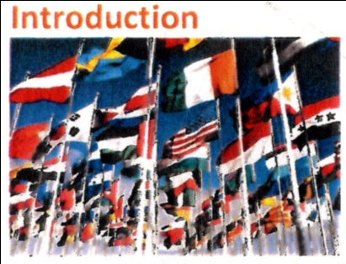
Even though you have planned and prepared really well for leaving home and travelling to study in a new country, you may still have a stressful experience due to the changes in general lifestyle and new customs.
This applies to irrelevant what country you come even though sine cultures are more similar than others.
What is Culture Shock ?
It includes the shock of a new environment, meeting lots of new people and learning the ways of a different country. It also includes the shock of being separated from the important people in your life such as family, friends, colleagues and teachers people you would normally talk to at times of uncertainty, people who give you support and guidance.

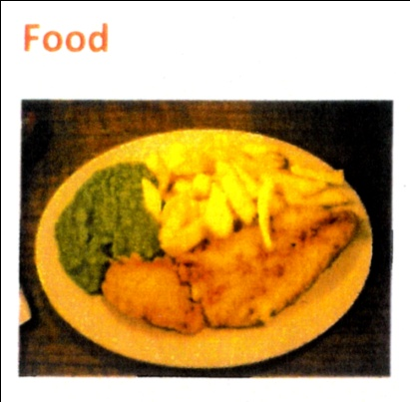
You may find British food strange as it may taste different or be cooked differently. Some people find British food bland or heavy compared to what they are used to. If you are in self-catering accommodation we have local shops and Supermarkets selling familiar foods. Make sure you eat plenty of fruit and vegetables.
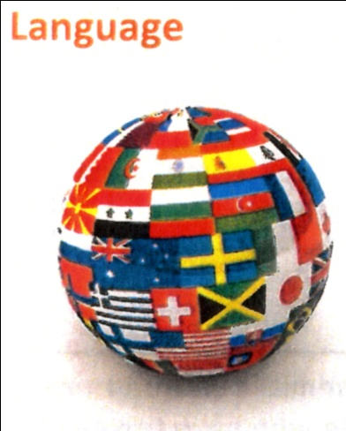
Constantly listening and speaking in a foreign language is tiring. If English is not your first language, you may find that you miss your familiar language which at home would have been part of your everyday environment. Even if you are a fluent English speaker, it is possible that the regional accents you discover when you arrive in the UK will make the language harder to understand. People may also speak quickly and you may feel embarrassed to ask them to repeat what they have said.
It is very normal to feel symptoms of Culture Shock and it is nothing to be ashamed of. If you are experiencing any of these symptoms of feelings, contact a member of our Student Support Team in the reception area or call us in confidence on 01792 459 615. We are here to help you.
Adapted from www.cityschoollanguages.co.uk

guidance : aide/conseil
bland : fade

