A tablet becomes your waiter with E la Carte
Diners can order via a tablet computer at 20 restaurants throughout the United States
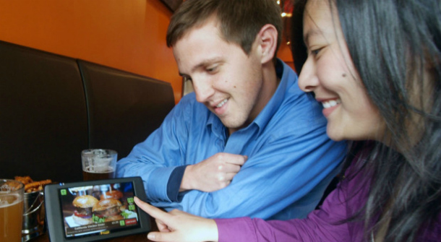
When you take into account all the minutes spent waiting between each stage of eating at a restaurant, dining out can be a time-consuming activity. The creators of E la Carte tablets envisage a modern and efficient dining experience with the use of their devices.
The tablets, which are considerably thicker than the sleeker iPad, are placed on every table of the restaurant. Guests can browse a digital version of the eatery’s menu, with high quality photos provided to wet their appetites. A shopping cart system allows them to check boxes to make their order, to which they can manually add any special requests.
The confirmed order is then wirelessly sent to the kitchen, which sends back an estimated wait time.While they wait for their food, guests have access to games, a drawing app about the local area. After the meal guests can pay using the tablet’s integrated card-reader. E la Carte can split the bill evenly or each guest can select their items and the device will calculate individual bills.
E la Carte can also calculate how much guests should pay for a 5, 10 or 20 percent tip. Guests can sign the screen to confirm their payment and enter the email address to which they would like the receipt to be sent. As the payments are processed, guests are prompted to sign up to a loyalty scheme or leave a comment.
E la Carte reports that the tablets can increase an establishment’s revenue by around 10 percent because the device is great for upselling high-margin items. For example, when a guest orders their meal, the device might ask ‘Do you want a salad with that?’ An accompanying appetising photograph tempts the guest, making them more likely to purchase the item.
Estimated additional revenue for the average restaurant works out at £300,000 a year.Although the device may appear to do everything a waiter does and more, the company advertises the product as a complement to rather than a replacement for in-person table service.
Waiters should be on-hand to assist guests, guiding them through the digital menu if desired. E la Carte suggests waiters may even benefit from bigger tips: with the tablet doing the maths, guests are more likely to leave a larger tip.
Further restaurants are on a waiting list to purchase E la Carte tablets – which are priced at under $100 a month – for their businesses.
by GABRIELLA BLAKE, AUGUST 2011
http://www.retail-digital.com/retail_technology/a-tablet-becomes-your-waiter-with-e-la-carte

Wirelessly : avec wifi

