BEAUJOLAIS: A TASTE FOR ALL OCCASIONS

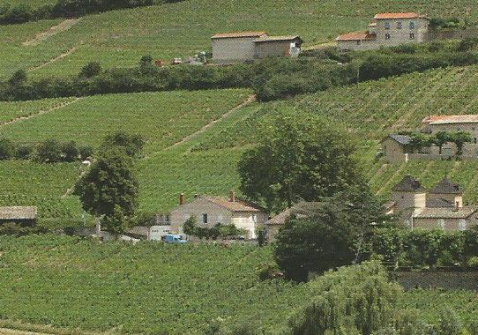
The region of Beaujolais produces some of the most appealing and accessible wines anywhere in France and indeed, the world. Whether you’re in the mood for a light and easy drinking Beaujolais to enjoy when the sun is shining, or a more full-bodied Beaujolais Cru to partner roasted meats on a chilly winter’s day, the wines are just as welcoming as the people who carefully craft them.

Within the Beaujolais appellation there are Beaujolais (for both red and white wines),
Beaujolais-Villages and then ten Cru villages which are indexed by their terroirs.

They include “soft and juicy” Chiroubles and Régnié, “tender” Fleurie, Saint Amour and Brouilly, and “robust” Côte de Brouilly, Juliénas, Chénas, Morgon and Moulin-à-Vent are characterized by their red fruit aromas and flavours of redcurrant and spice. An intense length in the mouth is unveiled once the wines have “done their Easter duty”, and have made the most of maturing for a few months before bottling.

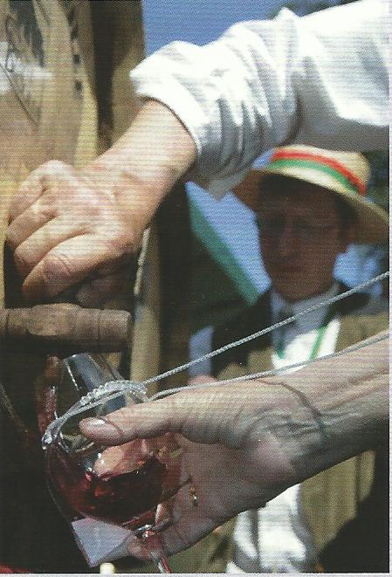
The key to these diverse reds is in the grape: Gamay. Growing in the Beaujolais region since the beginning of 17th century, this variety has accompanied the region during the evolution of the vineyards and collective vinegrowing tradition. And it is, of course, on the Beaujolais’ limestone-clay and granitic soils that this plant has found its true home. Nearly 70% of the 36 000 hectares of land planted with Gamay throughout the world is in Beaujolais.

Make sure you visit the region to really get the most out of the spirit of Beaujolais. As you travel along the Beaujolais Wine Route just north of Lyon, you will meet men and women whose personalities and life stories all differ, but who all live the same passion for the Beaujolais vineyard.

According to the winemakers who live and breathe Beaujolais, there are a few simple but important recommendations for getting the best of out the wines:

Beaujolais and Beaujolais-Villages should be served lightly chilled at around 13/14°C. The Beaujolais Crus are suited to serving at an average of 16°C, which can be knocked down a degree or two for a youthful Cru, or a degree or two warmer for wines that have had around three to five years in the bottle.

Surrey Magazine Spring number, 2012

