THE ART OF BLENDING
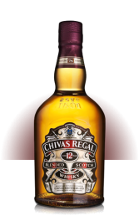

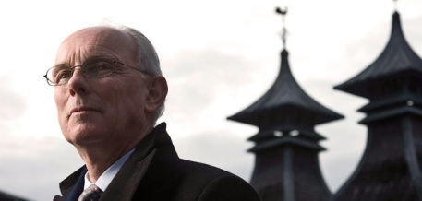

CHIVAS REGAL 12 Years Old, 18 Year Old, 25 years Old and the Chivas Brothers’ Blend each has its own unique formula and selection of many aged whiskies, giving them their own distrinct character, flavor and taste experience. For whisky to legally become Scotch, the new spirit must be matured for a minimum of three years in oak casks. For Chivas Regal, all the casks of whisky selected have been carefully matured for a least twelve years. It is the skill of the Master Blender to select the many different casks of malt and grain whiskies, all the correct age, harmonising the characters and flavours to ensure the superlative quality and consistent taste experience of Chivas Regal year after year.

Colin Scott explains: “ The art of the Master Blender in understanding the many different flavours in Scotch whisky is like the work of a composer : not only do you need to completely understand the musical characteristics of every instrument, but you must also understand how to combine them to built an unforgettable, spellbinding symphony “.

The traditions and fine art of blending Aged Scotch whiskies, pioneered by James and John Chivas
in the mid 1800 ‘s, have been carefully handed down over the generations to our Master Blenders. Today, Chivas Master Blender Colin Scott is the guardian oh these traditions that safeguard the integrity of Chivas Regal. The skills of the Master Blender only come from years of experience and a special passion for Scotch whisky.

The Art of Blending is to harmonise the characters of many selected malt and grain whiskies to produce brands of the highest quality, such as Chivas, that are consistent in flavours and taste from year to year.

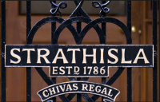

http:www.chivas.com/en/int/heritage/the-art-of-blending/

